|  |  |  |
| --- | --- | --- |
| **Project Report**  **On**  **LIBARARY MANAGEMENT SYSTEM**  **Session 2018-19**  **DATABASE MANAGEMENT SYSTEMS**  **Submitted By**  **Vishal Kumar**  **1803210181**  **Under the guidance of**  **Mrs. Nidhi Singh**  **ABES ENGINEERING COLLEGE, GHAZIABAD** | | |
|  |  |  |
| **AFFILIATED TO**  **DR. A.P.J. ABDUL KALAM TECHNICAL UNIVERSITY, U.P., LUCKNOW**  **(Formerly UPTU)** | | |

# STUDENT’S DECLARATION

I / We hereby declare that the work being presented in this report entitled “LIBRARY MANAGEMENT SYSTEM” (font size 14) is an authentic record of my / our own work carried out under the supervision of Mrs. “NIDHI SINGH” (font size 14)

The matter embodied in this report has not been submitted by me / us for the award of any other degree. (font size 12Arial 1.5 Line Spacing)

## Dated: Signature of students(s)

**(Name(s).......................)**

**Department: CSE**

This is to certify that the above statement made by the candidates is correct to the best of my knowledge.

**Signature of Supervisor**

TABLE OF CONTENTS

|  |  |  |
| --- | --- | --- |
| **S.NO** | Contents | Pg.No |
| 1. | Introduction | 4 |
| 1. | Data requirements   * Entities * Attributes * Relationships-cardinality | 5-6 |
| 2. | Entity Relationship Diagram | 6 |
| 3. | Schema Diagram | 7 |
| 4. | Class Diagram | 8 |
| 5. | Creating Database using ORACLE-10G | 8-13 |
| 6. | Test-case queries | 13-14 |
| 7. | Conclusion and References | 15 |

**PROBLEM STATEMENT**:

The problem occurred before having computerized system includes:

• File lost-

When computerized system is not implemented file is always lost because of human environment.Some times due to some human error there may be a loss of records.

• File damaged-

When a computerized system is not there file is always lost due to some accident like spilling of water by some member on file accidently. Besides some natural disaster like floods or fires may also damage the files.

• Difficult to search record -

When there is no computerized system there is always a difficulty in searching of records if the records are large in number.

• Space consuming -

After the number of records become large the space for physical storage of file and records also increases if no computerized system is implemented.

• Cost consuming-

As there is no computerized system the to add each record paper will be needed which will increase the cost for the management of library.

**INTRODUCTION**

A library is a collection of organized information and resources which is made accessible to a well-defined community for borrowing or reference sake. The collection of the resources and information are provided in digital or physical format in either a building/room or in a virtual space or even both. Library’s resources and collections may include newspapers, books, films, prints, maps, CDs, tapes, videotapes, microform, database etc. The main aim of this system is to develop a new programmed system that will conveying ever lasting solution to the manual base operations and to make available a channel through which staff can maintain the record easily and customers can access the information about the library at whatever place they might find themselves.

Library Management System allows the user to store the book details and the customer details. The system is strong enough to withstand regressive yearly operations under conditions where the database is maintained and cleared over a certain time of span. The implementation of the system in the organization will considerably reduce data entry, time and also provide readily calculated reports.

**OBJECTIVE**: - It keeps track of all the information about the books in the library, their cost, status and total number of books available in the Library. The user will find it easy in this automated system rather than using the manual writing system. The system contains a database where all the information will be stored safely.

**SOFTWARE AND HARDWARE REQUIREMENTS**

**SOFTWARE REQUIREMENTS** –

• Operating system- Windows 10 is used as the operating system as it is stable and supports more features and is more user friendly

• Database ORACLE 10G is used as database as it easy to maintain and retrieve records by simple queries which are in English language which are easy to understand and easy to write.

**HARDWARE REQUIREMENTS** -

➢ Intel core i3 7th generation is used as a processor because it is fast than other processors an provide reliable and stable and we can run our pc for longtime. By using this processor we can keep on developing our project without any worries.

➢ Ram 2 GB is used as it will provide fast reading and writing capabilities and will in turn support in processing .

Data Requirements

Entities

* CUSTOMER
* BOOKS
* PUBLISHER

Attributes

* CUSTOMER
* Customer_ID
* Customer_Name
* Address
* Street
* City
* State
* Pincode
* Contact_No.
* Registration_date
* BOOKS
* Book_ID
* Book_name
* Category
* Rental_price
* Author
* Status
* PUBLISHER
* Pub_ID
* Pub_Name
* Address
* Contact_No.

**RELATIONSHIP CARDINALITY**

* **CUSTOMER borrowed BOOKS** (1 – Many)
* **PUBLISHER published BOOKS** (1 – Many)

**ER DIAGRAM**

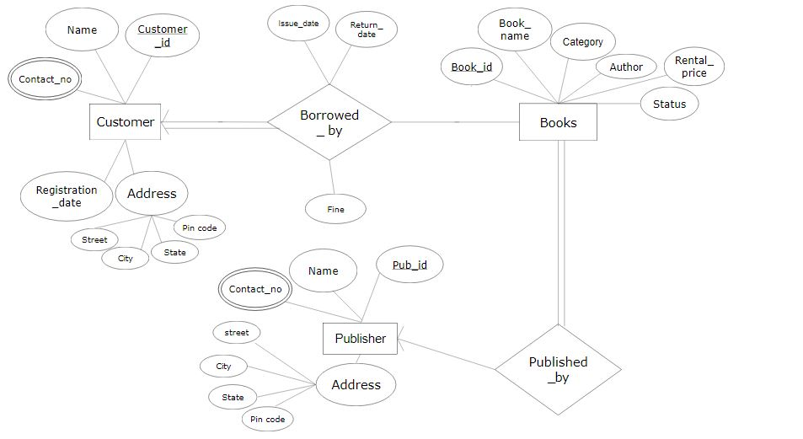

**SCHEMA DIAGRAM**

**CUSTOMER**

|  |  |  |  |  |  |  |  |  |  |  |
| --- | --- | --- | --- | --- | --- | --- | --- | --- | --- | --- |
| **Customer**  **_id** | **Name** | **Street** | **City** | **State** | **Pin**  **code** | **Registration**  **_date** | **Issue**  **_date** | **Return**  **_date** | **Fine** | **Book_id** |

**BOOKS**

|  |  |  |  |  |  |
| --- | --- | --- | --- | --- | --- |
| **Book_id** | **Name** | **Category** | **Author** | **Rental_price** | **Pub_id** |

**PUBLISHER**

|  |  |  |  |  |  |
| --- | --- | --- | --- | --- | --- |
| **Pub_id** | **Name** | **Street** | **City** | **State** | **Pincode** |

**CUST_contact_no**

|  |  |
| --- | --- |
| **Customer_id** | **Contact_no** |

**PUBL_contact_no**

|  |  |
| --- | --- |
| **Pub_id** | **Contact_no** |

**CLASS DIAGRAM**

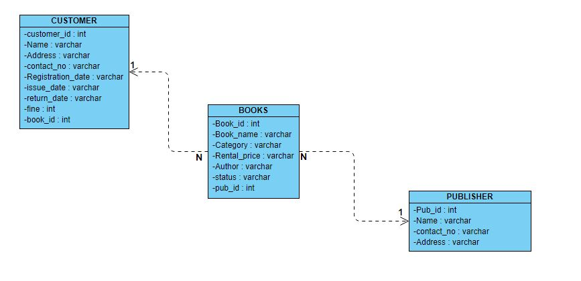

**CREATING DATABASE USING ORACLE-10G**

1. Create table customer(customer_id int, name varchar(50), address varchar(50), registration_date varchar(30), issue_date varchar(30), return_date varchar(30),

fine int, book_id int, primary key(customer_id), foreign key(book_id) references

books(book_id));

Desc customer;

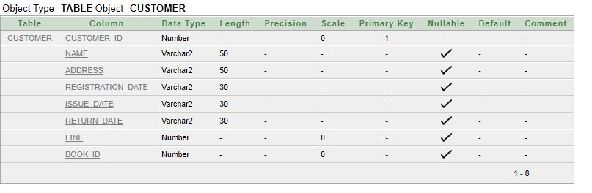

1. Create table books(book_id int , book_name varchar(50), category varchar(50) , rental_price int(10) ,status varchar(50), author varchar(50), pub_id int, primary key(book_id), foreign key(pub_id) references publisher(pub_id)) ;

Desc books;

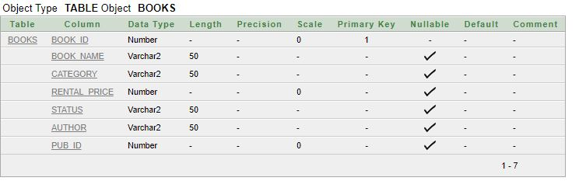

1. Create table publisher(pub_id int, name varchar(50), address varchar(50), primary key(pub_id));

Desc publisher;

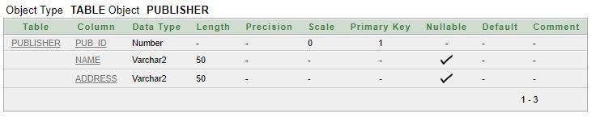

1. Create table cust_contact_no(customer_id int, contact_no int,

primary key(customer_id, contact_no), foreign key(customer_id) references customer(customer_id));

Desc cust_contact_no;

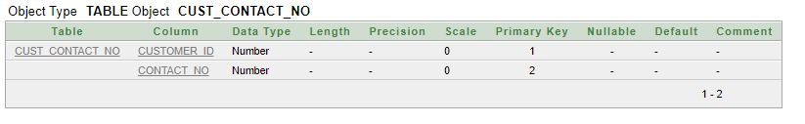

1. Create table publ_contact_no(pub_id int, contact_no int, primary key(pub_id, contact_no), foreign key(pub_id) references publisher(pub_id));

Desc publ_contact_no;

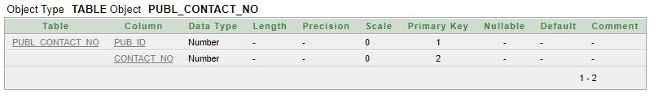

1. Insert into customer values(01,'cust1','d-1 noida','1-mar-2014','20-mar-2014', '30-mar-2014',0,1000);
   1. Insert into customer values(02,'cust2','b-1 delhi','2-mar-2017','15-mar-2017', '5-apr-

2017',10,1001);

* 1. Insert into customer values(03,'cust3','sector-11 noida','3-jun-2018', '10-jun-2018','15-jun-2018',0,1002);
  2. Insert into customer values(04,'cust4','dilshad garden delhi','4-jan-2019', '23-jan-2019','10-feb-2019',50,1003);
  3. Insert into customer values(05,'cust5','sector-15 noida','6-feb-2016','18-feb-2016', '25-feb-2016',0,1004);

Select * from customer;

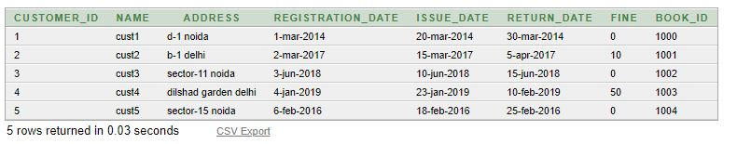

1. insert into books values(1000,'book1','comedy',5,'available','author1',100);
   1. insert into books values(1001,'book2','scifi',10,'available','author2',101);
   2. insert into books values(1002,'book3','romance',15,'available','author3',102);
   3. insert into books values(1003,'book4','thriller',20,'unavailable','author4',103);
   4. insert into books values(1004,'book5', 'horror',18,'unavailable','author5',104);

Select * from books;

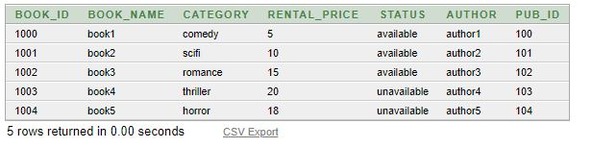

1. insert into publisher values(100,'pub1','delhi');
   1. insert into publisher values(101,'pub2','kanpur');
   2. insert into publisher values(102,'pub3','uttarpradesh');
   3. insert into publisher values(103,'pub4','lucknow');
   4. insert into publisher values(104,'pub5','mumbai');

Select * from publisher;

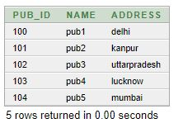

1. insert into cust_contact_no values(01,9749087298);
   1. insert into cust_contact_no values(02,9795075390);
   2. insert into cust_contact_no values(03,8984875939);
   3. insert into cust_contact_no values(04,6589898502);
   4. insert into cust_contact_no values(05,7990057309);

Select * from cust_contact_no;

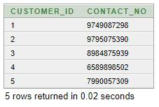

**10.**  insert into publ_contact_no values(100,9876543211);

10.1. insert into publ_contact_no values(101,8603744851);

10.2 insert into publ_contact_no values(102,9835785472);

10.3. insert into publ_contact_no values(103,9999558783);

10.4. insert into publ_contact_no values(104,8889874514);

Select * from publ_contact_no;

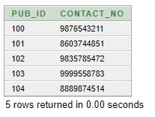

**TEST-CASE QUERIES**

1. insert into customer values(6,'cust6','tilak nagar, delhi','12-aug-2015','14-aug-2015','26-aug-2015',5,1005);

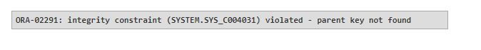

1. insert into books values(1005,'book6','detective',6,'available','author6',105);



1. insert into cust_contact_no values(6,9867984906);



1. insert into publ_contact_no values(105,8768475898);



1. insert into customer values(3,'cust6','tilak nagar, delhi','12-aug-2015','14-aug-2015','26-aug-2015',5,1005);

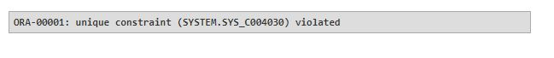

1. insert into books values(1003,'book6','detective',6,'available','author6',105);



1. insert into publisher values(104,'pub6','banglore');



1. insert into cust_contact_no values(01,9997895879);

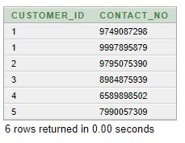

1. insert into publ_contact_no values(102,7654788588);

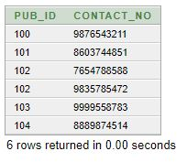

10.insert into cust_contact_no values(2,9795075390);



11. insert into publ_contact_no values(101,8603744851);



**CONCLUSION**

* SQL database management application which is very well used in the modern world in organising and manipulating a database.
* Though SQL doesn’t have the GUI interface like Microsoft access is having and they all manage the database comfortable.
* Depending on the user or users, if an organisation has multiple users then they should go for SQL server based application.
* This project shows how to create tables in SQL and how to create simple data manipulation language and data definition language with how to execute them.
* It also shows how relationships are established with the concepts of primary and foreign key within a table.
* Lastly, the project shows how queries are created in SQL server, queries like the create command, view, update, alter etc.

**REFERENCES**

* [http://people.cs.pitt.edu/~chang/156/03ERmodel.html](http://people.cs.pitt.edu/%7Echang/156/03ERmodel.html)
* <http://www.academia.edu/13780884/Database_system_for_library_man> agement_system
* https://lbsitbytes2010.wordpress.com/2013/09/21/er-diagram-of- library-management-rno15s5cs2/
* https://[www.slideshare.net/fiu025/library-management-](http://www.slideshare.net/fiu025/library-management-) 32343393?next_slideshow=1
* <http://www.c-sharpcorner.com/UploadFile/ea3ed6/database-design-for-> library-management-system/
* <http://stackoverflow.com/questions/17641134/what-is-different-> between-er-diagram-and-database-schema